

POLYTECHNIC UNIVERSITY OF CHIAPAS

SOFTWARE DEVELOPMENT ENGINEERING

**SUBJECT:** ENGLISH IV

1st CUT PROJECT

**TEACHER:** LEONARDO ABIRAN VELAZQUEZ PEREZ

**STUDENT:** ELIAS ROBLERO PEREZ

**ENROLLMENT:** 183414

4 ° A

TUXTLA GUTIERREZ CHIAPAS SEPTEMBER 25, 2019

**REGULAR VERBS**

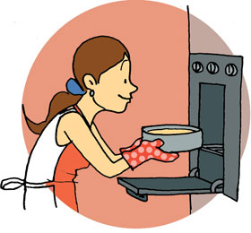

**BAKE**

**-SIMPLE PAST:** BAKED

**-SPANISH:** HORNEAR

* I bake some chocolate cookies sometimes
* I baked a delicious bread
* You didn’t bake the weekend

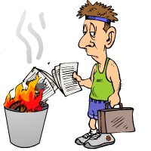 **BURN**

**-SIMPLE PAST:** BURNED

**-SPANISH:** QUEMAR

* I burn my white sheets for forgetfulness
* I burned my homework by accident
* You didn’t burn those sheets

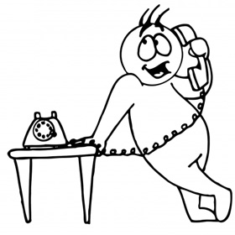 **CALL**

**-SIMPLE PAST:** CALLED

**-SPANISH:** LLAMAR

* I call my friend every weekend
* Juan called his dad yesterday
* Juan didn’t call his parents yesterday



**CELEBRATE**

**-SIMPLE PAST:** CELEBRATED

**-SPANISH:** CELEBRAR

* I celebrate when I pass my exam
* He celebrated his birthday on Friday
* She didn’t celebrate her graduation

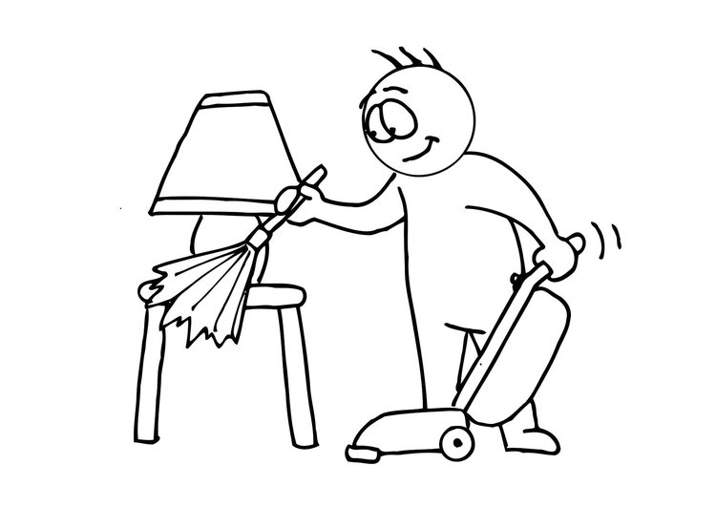 **CLEAN**

**-SIMPLE PAST:** CLEANED

**-SPANISH:** LIMPIAR

* I clean my bedroom
* He cleaned his dog's house
* She didn’t clean the kitchen

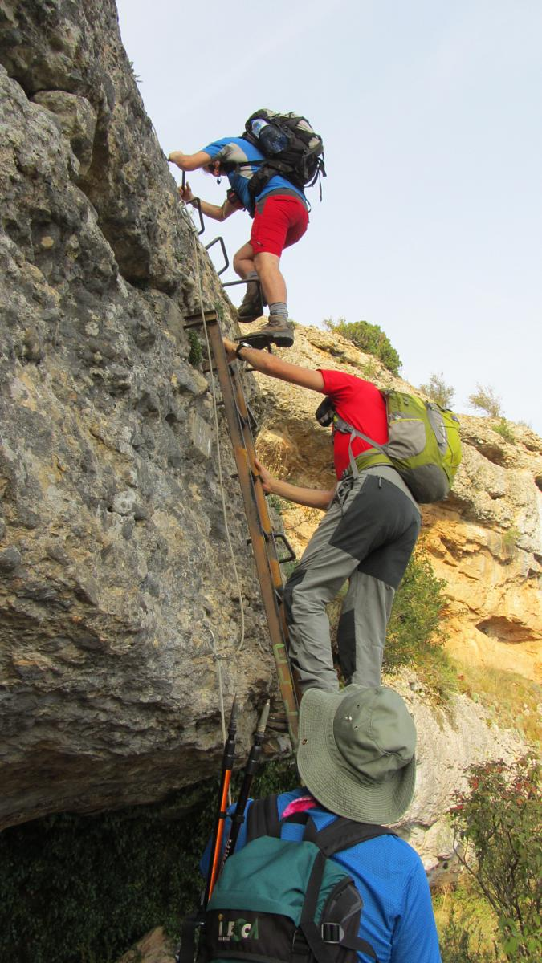

**CLIMB**

**-SIMPLE PAST:** CLIMBED

**-SPANISH:** TREPAR

* I climb a big tree
* He climbed a steep mountain
* She didn’t climb the apple tree

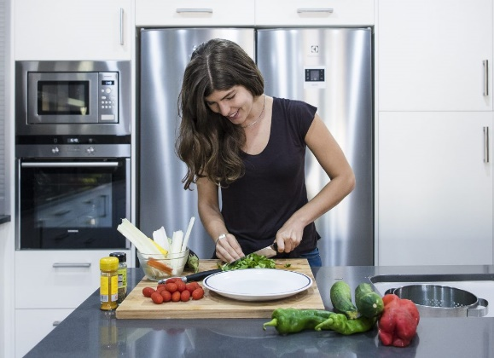 **COOK**

**-SIMPLE PAST:** COOKED

**-SPANISH:** COCINAR

* I cook some rancher eggs
* He cooked a delicious lasagna
* She didn’t cook a sandwich yesterday morning

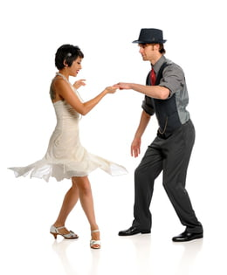

**DANCE**

**-SIMPLE PAST:** DANCED

**-SPANISH:** BAILAR

* I dance very good
* She danced at the party on saturday
* He didn’t dance with his girlfriend

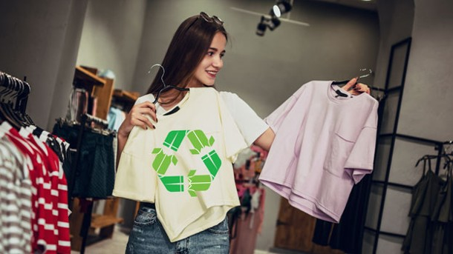 **DRESS**

**-SIMPLE PAST:** DRESSED

**-SPANISH:** VESTIR

* I dress my dogs on Halloween
* She dressed her dolls
* She didn’t dress the child god

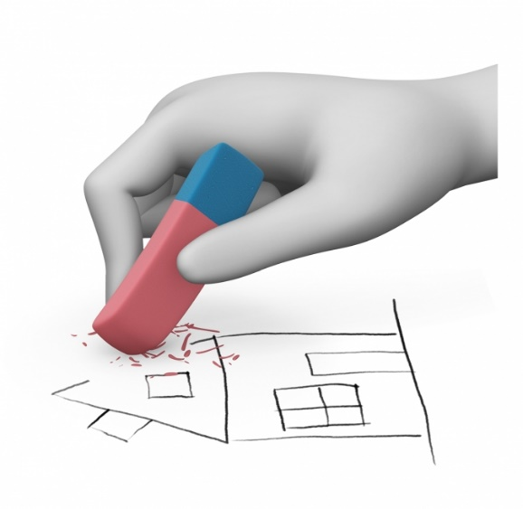

**ERASE**

**-SIMPLE PAST:** ERASED

**-SPANISH**: BORRAR

* I erase my math exercises when they are wrong
* He erased his messages
* You didn’t your notes

 **EXECIRSE**

**-SIMPLE PAST:** EXERCISED

**-SPANISH:** HACER EJERCICIO

* I exercise sometimes
* He exercised in the park
* She didn’t exercise yesterday



**FIX**

**-SIMPLE PAST:** FIXED

**-SPANISH**: REPARAR

* I fix my cell phone
* He fixed a computer
* She didn’t fix her makeup box

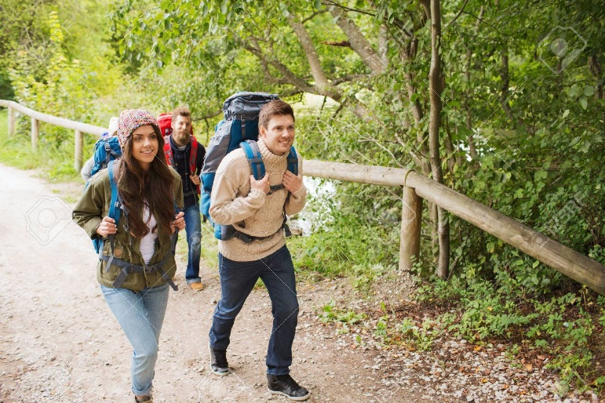 **HIKE**

**-SIMPLE PAST:** HIKED

**-SPANISH**: IR DE EXCURSION

* I hike with my parents
* He hiked with his girlfriend
* She didn’t hike yesterday



**JUMP**

**-SIMPLE PAST:** JUMPED

**-SPANISH**: SALTAR

* I jump very high
* He jumped the lake
* She didn’t jump in the jumper

** LEARN**

**-SIMPLE PAST:** LEARNED

**-SPANISH**: APRENDER

* I learn to drive with my dad
* He learned sign language
* She didn’t learn English

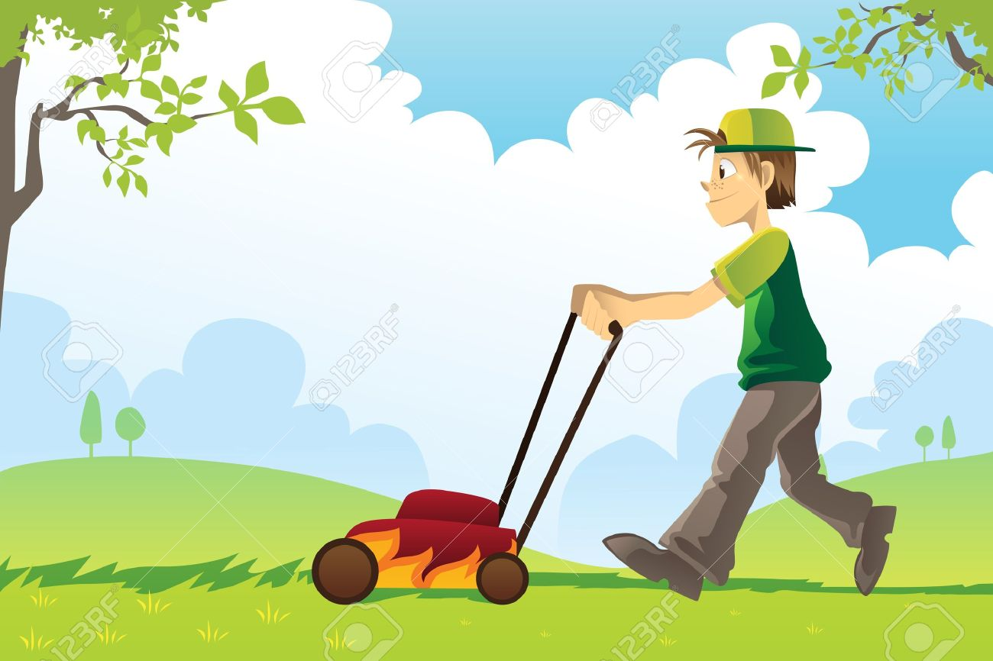 **MOW**

**-SIMPLE PAST:** MOWED

**-SPANISH:** CORTAR EL PASTO

* I mow in my house
* She mowed yesterday
* He didn’t mow on the weekend

 **PAINT**

**-SIMPLE PAST:** PAINTED

**-SPANISH:** PINTAR

* I paint very good
* She painted a very beautiful picture
* He didn’t paint his house

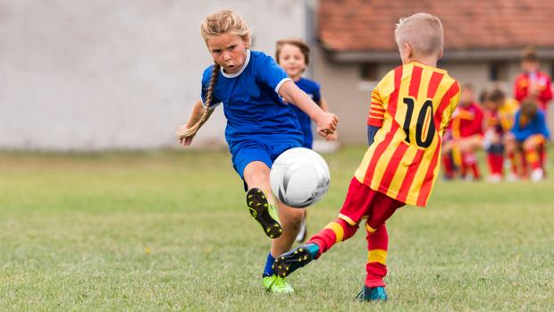

**PLAY**

**-SIMPLE PAST:** PLAYED

**-SPANISH:** JUGAR

* I play football soccer in the park
* He played video games
* She didn’t play volleyball

 **RECORD**

**-SIMPLE PAST:** RECORDED

**-SPANISH:** GRABAR

* I record a voice audio in whatsApp
* He recorded a nice song
* She didn’t record a music video

 **REST**

**-SIMPLE PAST:** RESTED

**-SPANISH:** DESCANSAR

* I rest after school
* He rested a lot the weekend
* She didn’t rest from her university

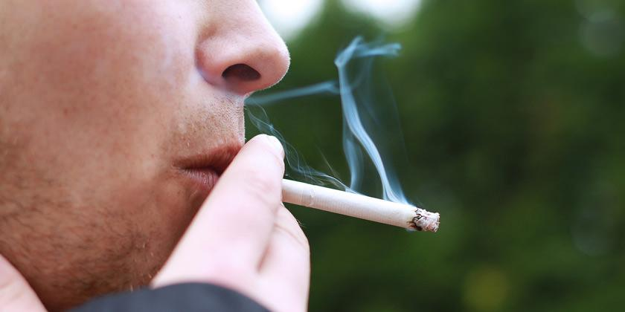 **SMOKE**

**-SIMPLE PAST:** SMOKED

**-SPANISH:** FUMAR

* I smoke hardly ever
* He smoked in the park
* She didn’t smoke in the hospital

 **STUDY**

**-SIMPLE PAST:** STUDIED

**-SPANISH:** ESTUDIAR

* I study in my room
* She studied last weekend
* You didn’t study for the exam

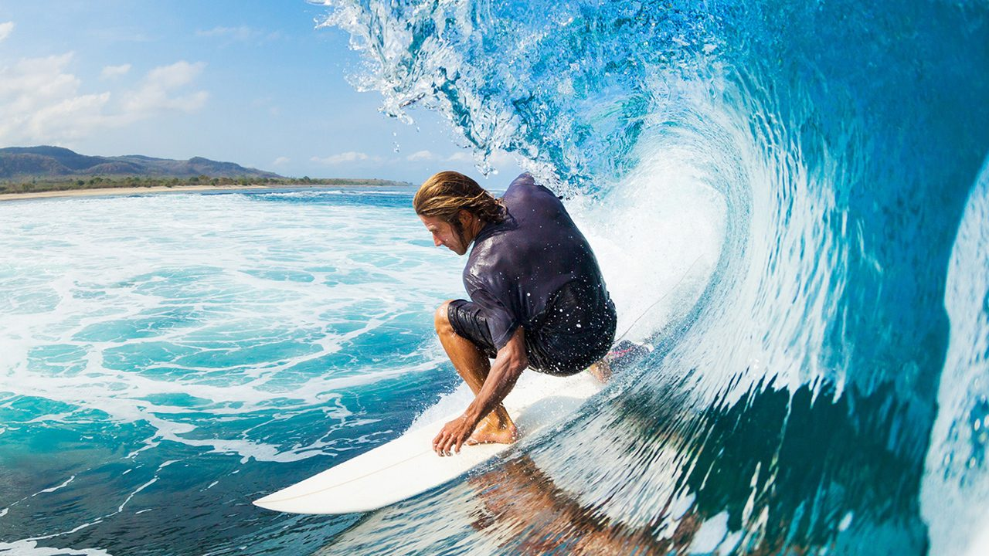 **SURF**

**-SIMPLE PAST:** SURFED

**-SPANISH:** SURFEAR

* I surf in the beach
* She surfed with her friends
* He didn’t surf yesterday



**TRAVEL**

**-SIMPLE PAST:** TRAVELLED

**-SPANISH:** VIAJAR

* I travel with my family
* She travelled on the past vacation
* You didn’t travel to Europe

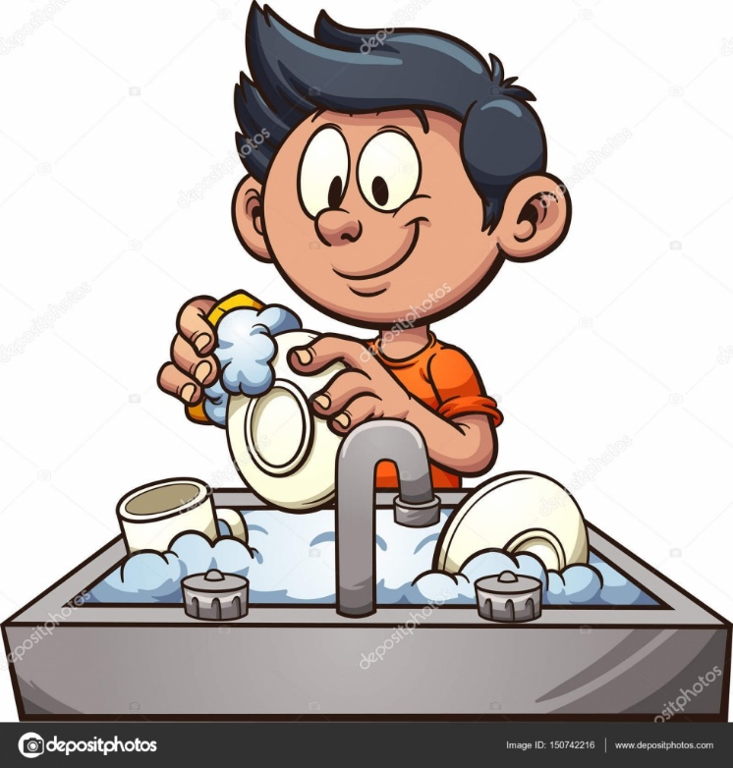 **WASH**

**-SIMPLE PAST:** WASHED

**-SPANISH:** LAVAR

* I wash my car
* He washed his clothes
* I didn’t wash my underpants

**IRREGULAR VERBS**

**HIT**

-**SIMPLE PAST:** HIT

-**SPANISH:** PEGAR

* I hit a soccer ball
* He hit a bicycle by accident
* She didn’t hit her car with the pole

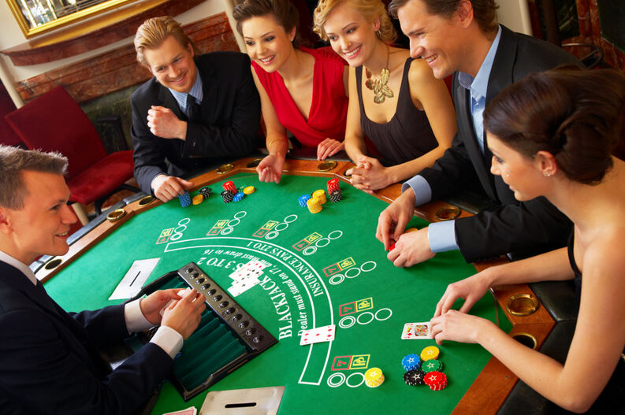

**BET**

**-SIMPLE PAST:** BET

-**SPANISH:** APOSTAR

* I bet on dominoes
* He bet a lot of money
* She didn’t bet in the casino

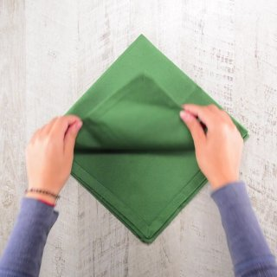 **BEND**

**-SIMPLE PAST: BENT**

**-SPANISH: DOBLAR**

* I bend my my clothes in my closet
* He bent his book
* She didn’t bend her blouse

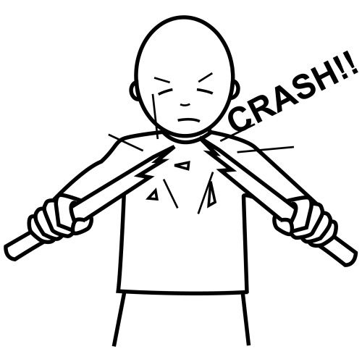

**BREAK**

**-SIMPLE PAST:** BROKE

**-SPANISH:** ROMPER

* I break my old notebooks
* I broke my jeans
* You didn’t break those toys

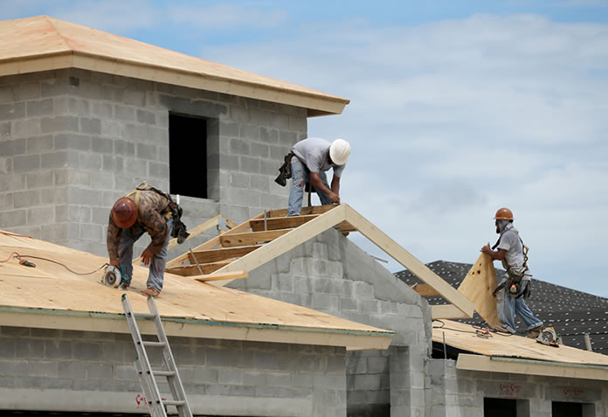 **BUILD**

**-SIMPLE PAST:** BUILT

**-SPANISH:** CONSTRUIR

* I build a house for my dogs
* He built a beautiful table
* You didn’t build your model for the school

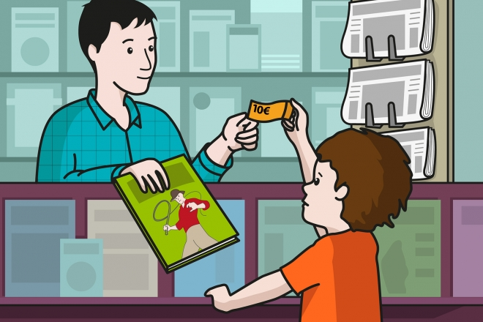

**BUY**

**-SIMPLE PAST:** BOUGHT

**-SPANISH:** COMPRAR

* I buy my school supplies
* She bought vegetables for food
* He didn’t buy his car this year

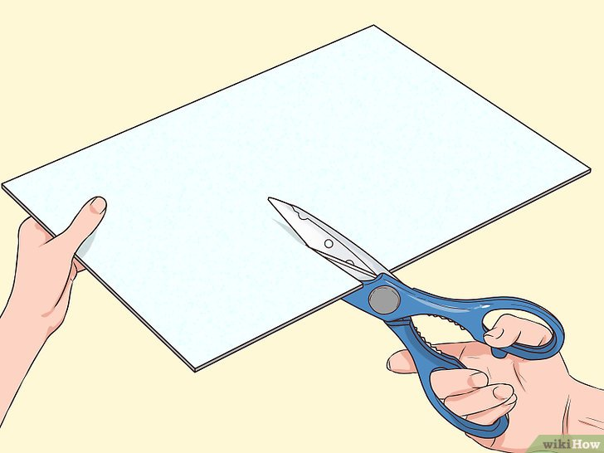 **CUT**

**-SIMPLE PAST:** CUT

**-SPANISH:** CORTAR

* I cut my hair every month
* He cut a wooden board yesterday
* She didn’t cut her apple tree

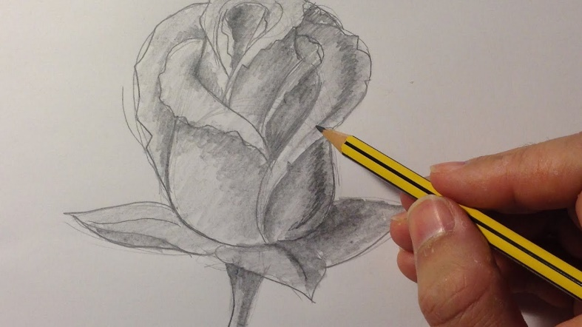

**DRAW**

**-SIMPLE PAST:** DREW

**-SPANISH:** DIBUJAR

* I draw sometimes
* He drew a beautiful landscape
* You didn’t draw your family tree

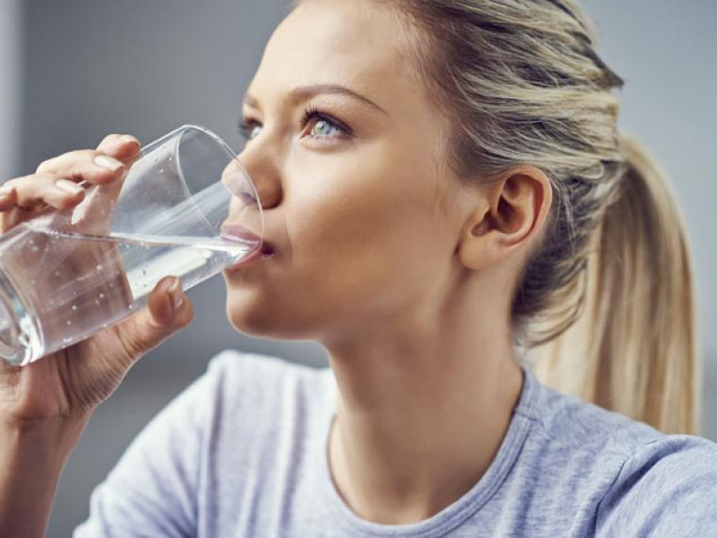 **DRINK**

**-SIMPLE PAST:** DRANK

**-SPANISH:** BEBER

* I drink coffee every night
* He drank a beer
* You didn’t drink a glass of cold water yesterday

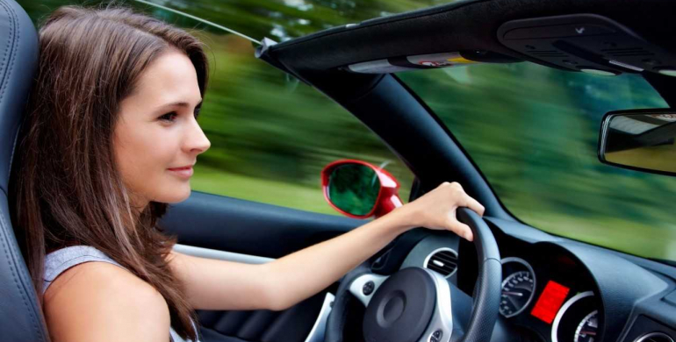

**DRIVE**

**-SIMPLE PAST:** DROVE

**-SPANISH:** MANEJAR

* I drive my father's car
* He drove the bus
* She didn’t drive her bicycle

 **EAT**

**-SIMPLE PAST:** ATE

**-SPANISH:** COMER

* I eat at 2:00 pm
* He ate a hamburguer
* She didn’t eat her breakfast

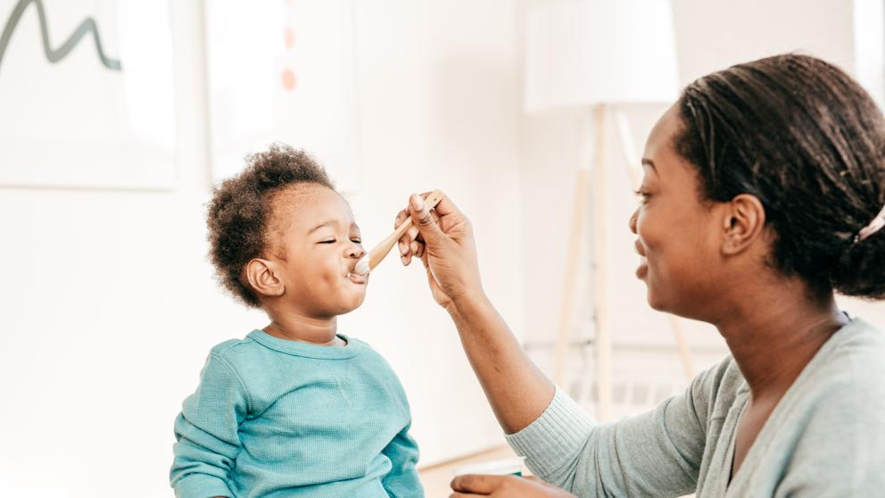

**FEED**

**-SIMPLE PAST:** FED

**-SPANISH:** ALIMENTAR

* I feed my dog
* He fed his turtle
* She didn’t feed her baby on friday

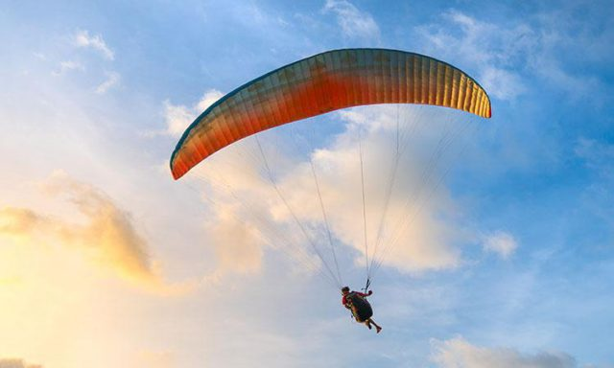 **FLY**

**-SIMPLE PAST:** FLEW

**-SPANISH:** VOLAR

* I fly my drone
* Juan flew to Paris last month
* Rosa didn’t fly her kite

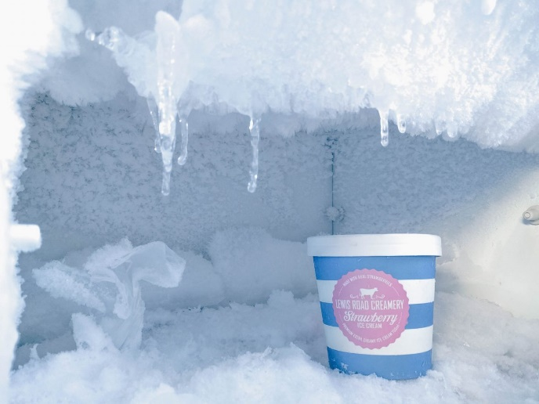

**FREEZE**

**-SIMPLE PAST:** FROZE

**-SPANISH:** CONGELAR

* I freeze some coconut popsicles
* Mario froze some cupcakes in the fridge
* María didn’t freeze a few pieces of meat

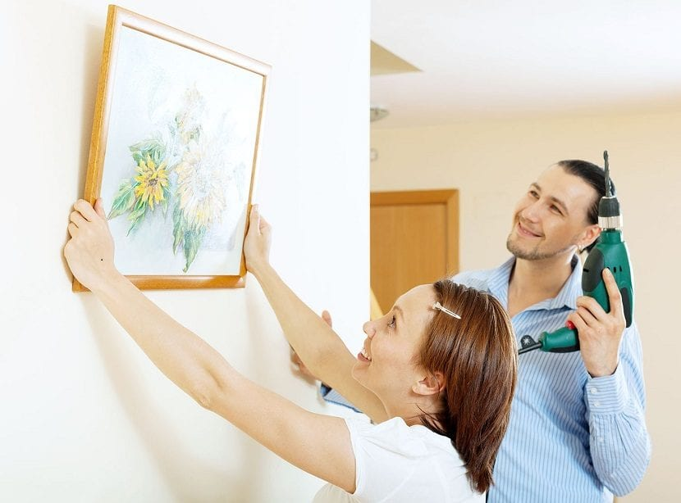 **HANG**

**-SIMPLE PAST:** HUNG

**-SPANISH:** COLGAR

* I hang my clothes
* Jacqueline hung her towel in the courtyard
* Miguel didn’t hang his canvas



**PAY**

**-SIMPLE PAST:** PAID

**-SPANISH:** PAGAR

* I pay my university registration
* José paid the money he owed
* Marisol didn’t pay the water bill

 **READ**

**-SIMPLE PAST:** READ

**-SPANISH:** LEER

* I read a book
* Joaquín read a news on the internet
* You didn’t read your investigation

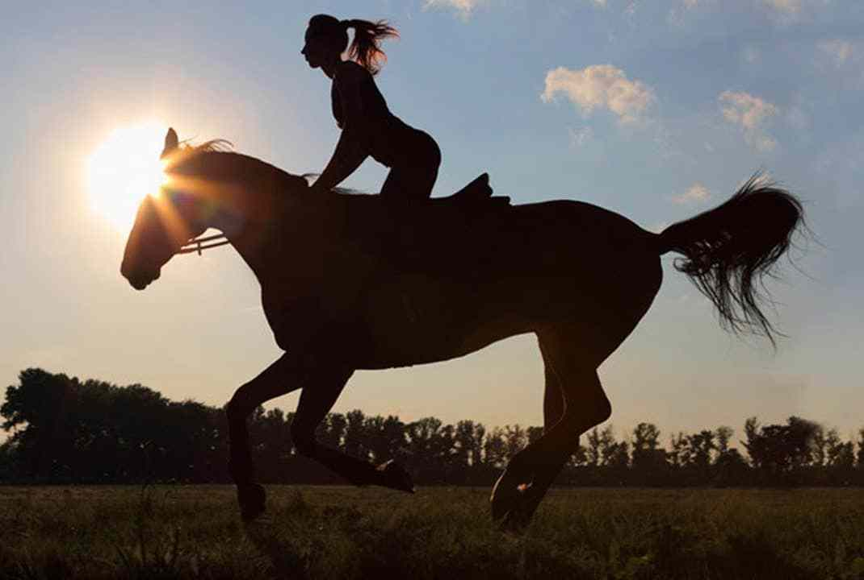

**RIDE**

**-SIMPLE PAST:** RODE

**-SPANISH:** MONTAR

* I ride my grandfather's horse
* He rode a very large horse
* Emilia didn’t ride a camel in the desert

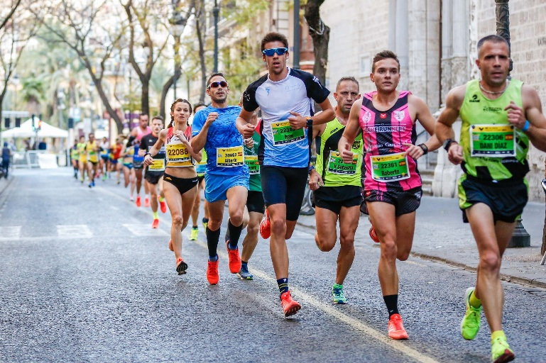 **RUN**

**-SIMPLE PAST:** RAN

**-SPANISH:** CORRER

* I run very fast
* He ran a marathon
* She didn’t run in the stadium

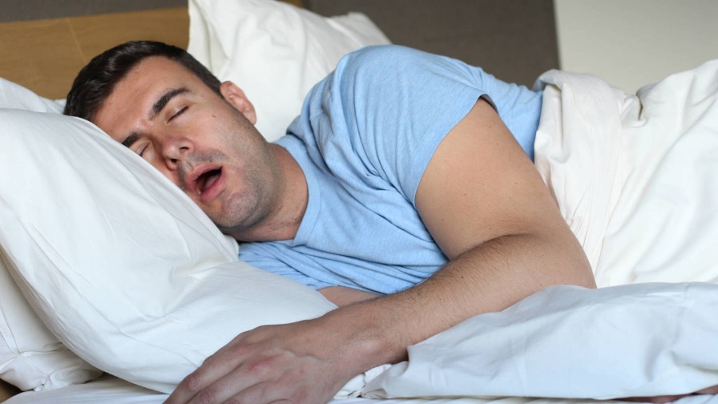

**SLEEP**

**-SIMPLE PAST:** SLEPT

**-SPANISH:** DORMIR

* I sleep in my bed
* Enrique slept at his girlfriend's house
* Martina didn’t sleep with her neighbour

 **SING**

**-SIMPLE PAST:** SANG

**-SPANISH:** CANTAR

* I sing everyday in my house
* Felipe sang in the rock concert
* Oscar didn’t sing in the church

**SWIM**

**-SIMPLE PAST:** SWAM

**-SPANISH:** NADAR

* I swim in my friend's pool
* Andrés swam in the swimming competition
* 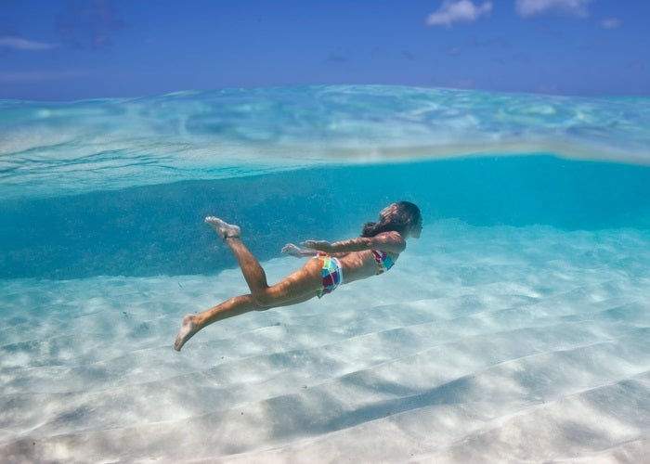Brenda didn’t swim at Friday's party